**Cloud Computing**

**Practical 1**

Practical-1 Infrastructure as a service using AWS.

#creating an ubuntu instance

Step 1 :Creating (Launching )an instance and creating a key pair for the same .

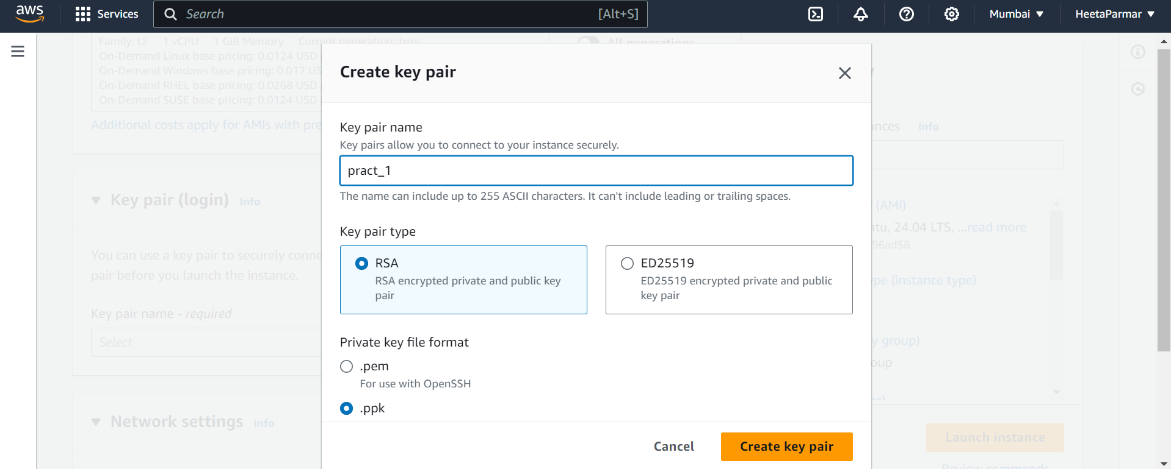

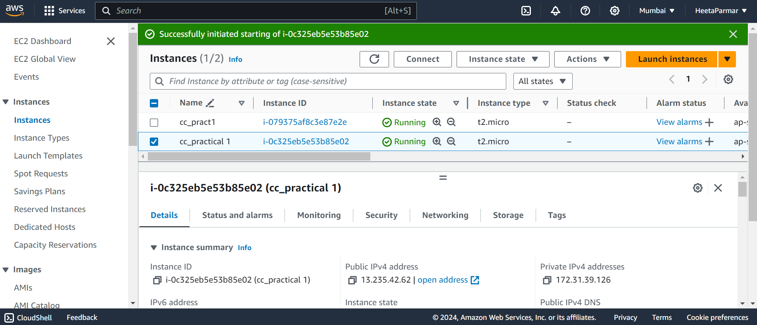

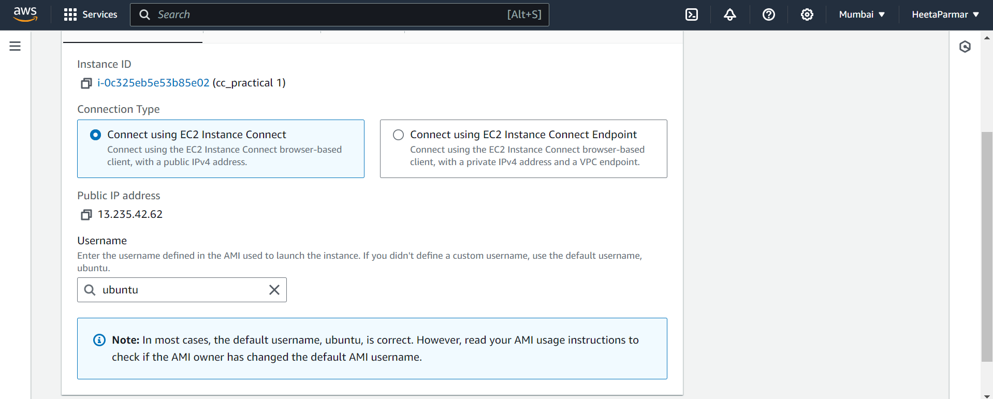

#performing the commands on ubuntu platform .

